

**jaelapps**

*Mobile App User Manual*

**Copyright Statement**

Copyright ©Jael Application, 2021. All rights reserved.

Android is a registered trademark of Google.

Windows and MS – DOS are registered trademarks of Microsoft corporation.

All other trademarks and copyrights referred to are the property of their respective owners.

Distribution of modified versions of this document is allowed for educational purposes.

DOCUMENTATION IS PROVIDED FOR THE PURPOSE OF THIS ASSIGNMENT.

Table of contents

1.) Introduction …………………………………………………………………………………..…… 4

1.1 What is jaelapps mobile app? ...................................................... 4

2.) How to……………………………………………………………………………………….……….. 5

2.1 View Messages………………………………………………………………………. 5

2.2 Contact Admin..………………………………………………………………….... 6

2.3 Access Admin Page...…………………………………………………………..…. 7

**1.) INTRODUCTION**

**1.1** What is jaelapps mobile app?

jaelapps is a mobile app that contains a motivation app. This app encourages and motivates the user out of depression, sadness and mental sickness.

**Which devices does the mobile app support?**

It can be installed on Android mobile phones and tablets operating system.

**How it works**

After installation on your android phone you go to apps and choose Jaelapps, once clicked, the motivator app will pop up on the screen.

**Jael Application allows you to:**

* View Messages (memes).
* Contact a clergyman, psychologist or counsellor.
* Admin login.(for admin only)
* View Clients. (for admin only)

**2.) HOW TO**

**2.1** View Messages

To view inspiring and motivational messages, please click on the green button. It will lead you to the memes page.



Once the button is clicked, the memes page will be displayed as seen below



**2.2** Contact Admin

To contact admin about reaching out to a psychologist, clergyman or counsellor please press the red button.

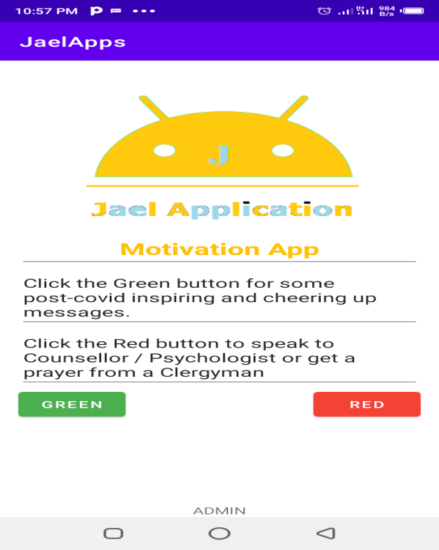

Once the red button is pressed it will take you to the page to enter your contact details whereafter you will be contacted by an Admin of jaelapps.

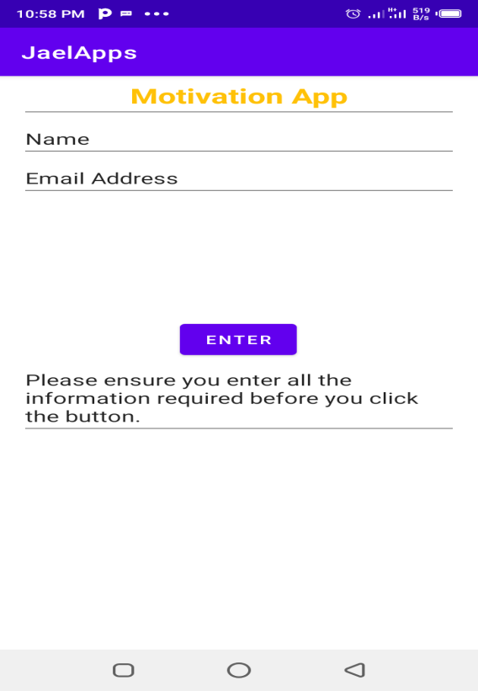

**2.3** Access Admin page

To view the admin page you will be prompted to enter a password and login id. It as follows. Id: admin password: 6789

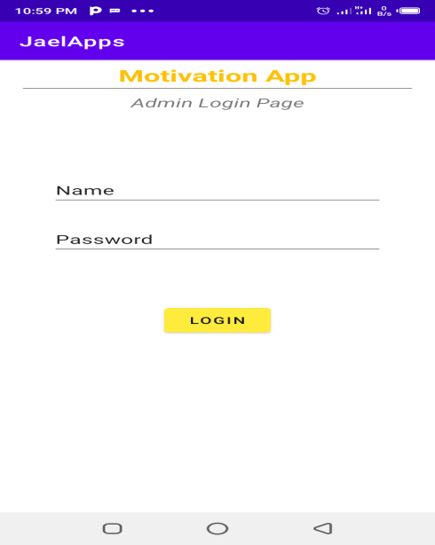

Once logged in, it will take you to the admin page to view clients who have indicated interest in speaking with a psychologist, counsellor or clergyman.

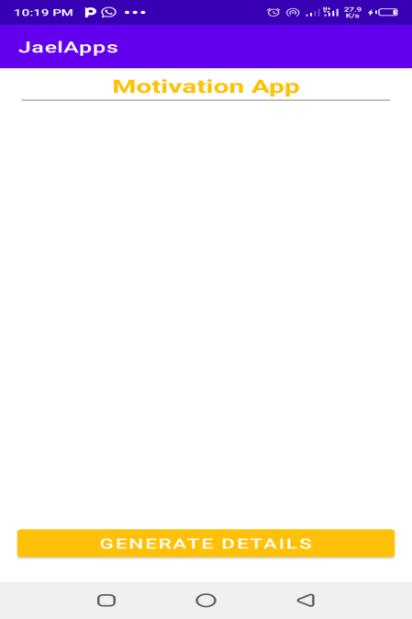

Once the button is clicked, clients info stored to database will be generated.